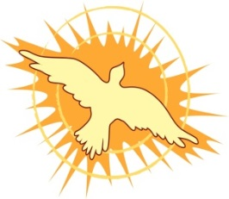
THE CHURCH OF SAINT MARY
Faith Formation Program
McHenry, IL 60050

June 16, 2021

Dear Confirmation Families,
Confirmation is a two year preparation program for all students that are both parishioners of
St. Mary and are attending St. Mary’s Faith Formation Program or Montini. If your child is entering 7th grade in the fall or is in 8th grade or up in 2021 and you wish for them to make their Confirmation they should be registered in the Confirmation program which begins with our opening Mass celebration for all students and parents September 8, 2021 at 6:00pm

*Our first Confirmation sessions will be October 13, 2021. All Confirmation students and parent(s) should be in attendance at this first Confirmation Session which will meet in Mary Hall.

Confirmation classes will be held every other Wednesday night. I have included a registration form and schedule with this letter. Confirmation students will also be required to attend retreats; dates for these will be announced as soon as they are available. Please note that the enclosed calendar is tentative and is subject to change as new scheduling becomes available to me.
I am looking forward to working with you & your child(ren). Please feel free to contact me with any questions or concerns that you may have. I will return your email or call as soon as possible.
Have a blessed summer break,

Tammy Miller
Director of Faith Formation
tmiller@stmarymchenryil.org
(815) 385-0024

